LAB REPORT

for
Lab Assignment #4:
Modular ALU

Table of contents:

1. Introduction………………………………………………………………….………..1

2. Functional Behavioral Requirements……………….………………………….…..1

3. Design Context……………………………………………………………………….1

4. Simulation Testing Plan………….………………………………….………..……..7

5. Prototype Testing Plan…………….………….…………..…………….....………..8

6. Result of Testing………...………………………………………………….………..8

7. Answer To Questions…...………………………………………………….………..8

8. Conclusion………….……………………………………………………….………..9

1. Introduction

“In this assignment, students will create a modular logic design to perform any of several different arithmetic and/or logical operations on 8-bit inputs representing signed input
integers in the range [−128, +127], and display the results in an appropriate humanreadable form. This assignment is to be carried out as a structured design process, though
with less documentation required than in lab #1. Students should design and test their
circuits at home in the simulator, and then test their designs in lab on the boards.

-- quoted from Lab Assignment #4 document.

2. Functional Behavioral Requirements

System-level functional requirement1: Two 8-bit input buses as input, each of which may represent a signed integer from −128 to +127, perform any of four different user-selected arithmetic or logical operations on these two bytes
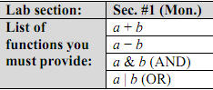
System-level functional requirement2: Display the result in a form that is
visible to and readily understandable by a human viewer.

3. Design Context
This section lays out the design context, the larger system within which our Smoke Alarm Controller subsystem will function.
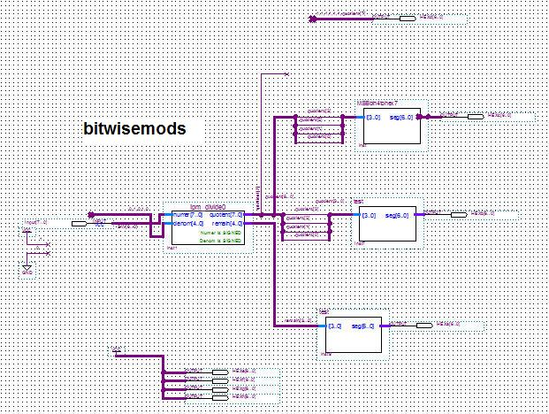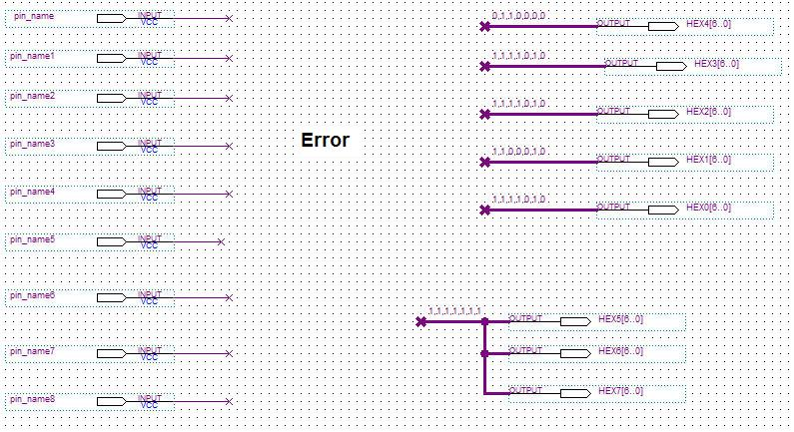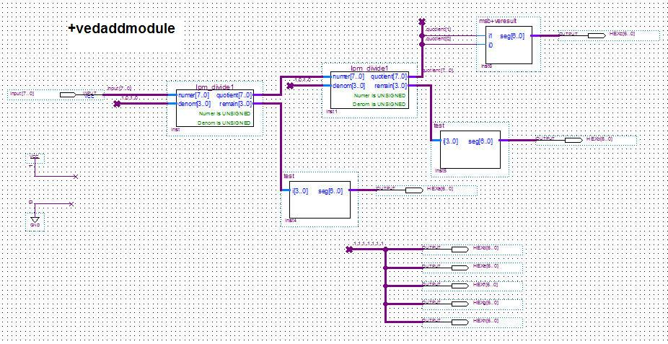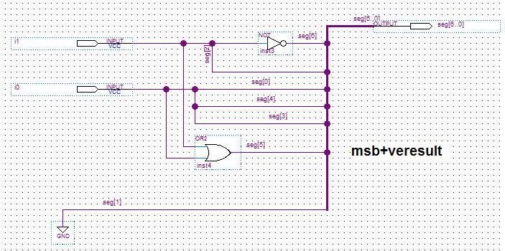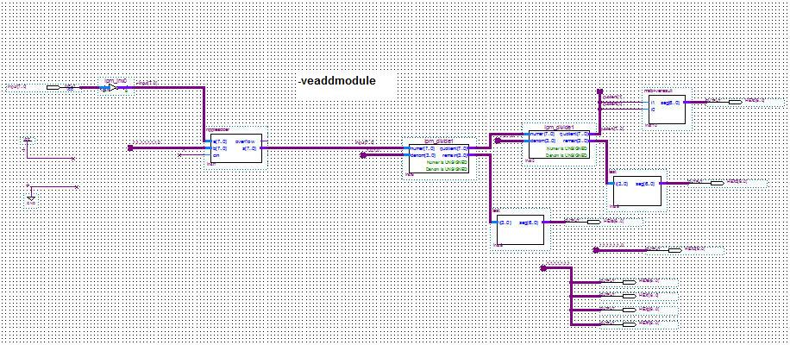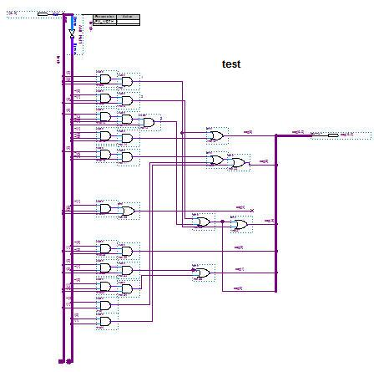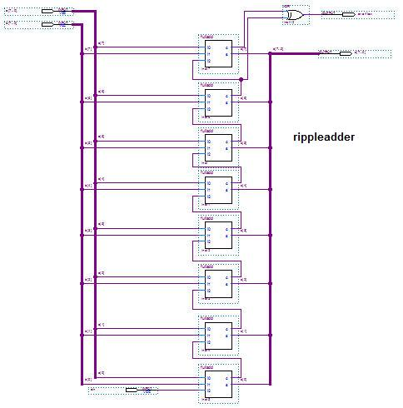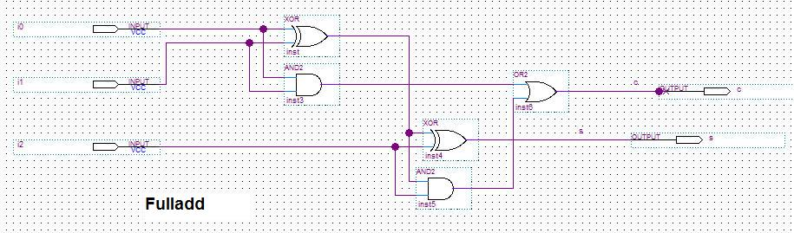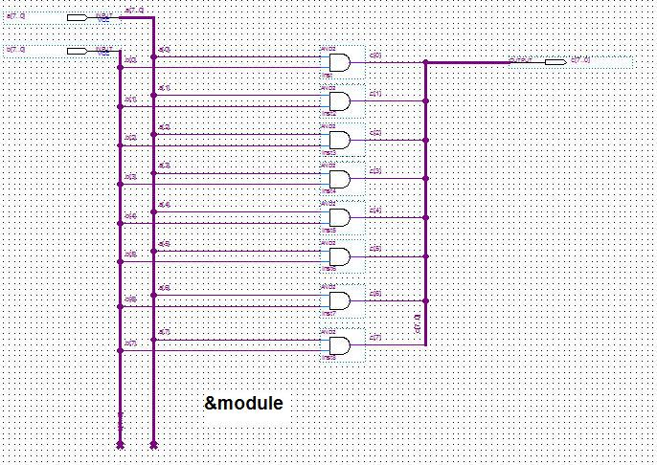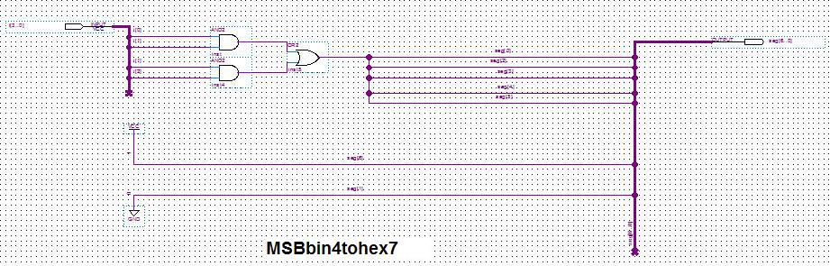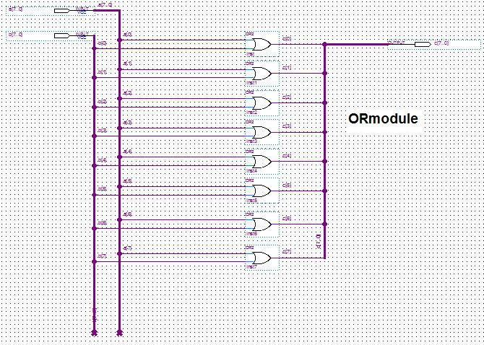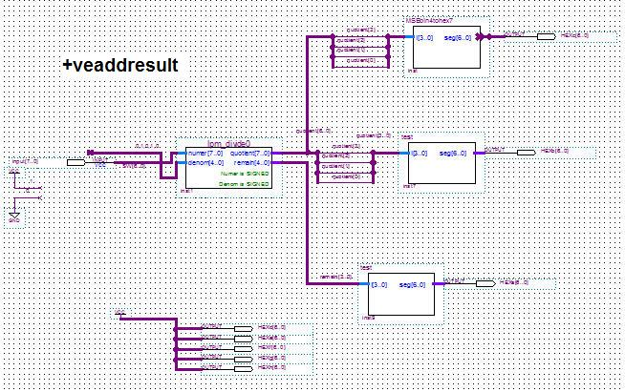

4. Simulation testing plan
With the use of Quartus and the “Simulator Tool” we can make sure the outputs are what we expect. The steps include creating input waveforms for the input nodes, starting the simulation, viewing the report, comparing waveforms with output waveforms, and lastly making sure the delay is non due to functional simulation.

5. Prototype testing plan
During the lab, to systematically test all of the design functional requirements I will take the following steps:
Step1: Make sure the program is compiled correctly.
Step2: Test each switch function “+,-,&,|”
Step3: Test each of the function for each switch.

6. Result of testing
After completing the entire circuit (including sub circuits), there were compile issues. The name “&module” was not accepted due to the “$”, so we changed It to “ANDModule”. Also there were many other naming issues of busses; so many names had to be changed. Lastly, we used an XOR gate when we should have used an XNOR, so we fixed that.
We then changed the module that deals with negatives to a Quartus megafunction that takes the absolute value. Another problem occurred when updating the blocks, you have to save the file first and then override the old blocks; that caused some problems until it was fixed.
We used “HEXa[6..0]”, for a few buses, but the compiler read it as it needed to convert HEXa, when we just had it as a label. So we changed all the HEXabc’s to HEX<name>.
The last thing we had to change were the connecting buses on the multiplier because “1” was paired with “3”, and “3” with “1”. It showed, for example, the output as 821 instead of 126.
After all these errors were corrected, the circuit worked just as directed.

7. Answers to Questions

Question #1.
The appropriate input device to use for the two eight-bit inputs would be the switches on the DE2 board.

Question #2.
The base what I will display the output in will be base ten because that is easily readable buy humans.

Question #3.
I will visually indicate the sign of the result by using the 7segment display to show a “-“.

Question #4.
If the results are outside the range of numbers that can be displayed, I will print a error message on the 7 segment display. The circuit is shown above.

Question #6.
An extra visible output I could provide that might make prototype testing easier are negative signs on the results.

Question #9.
As shown above in the pictures.

8. Conclusion

This assignment helped in the understanding of two’s-complement numbers and arithmetic performed on them. Also it understanding of how to put together ALUs from scratch using standard modular components. It gives additional practice at wiring up, simulating, and debugging modular designs using the Quartus tool. Lastly it emphasizes the ability to go through a structured design process with all appropriate documentation.

